ICCF Needs your support!
In the name of God, The Compassionate, The Merciful.

Salam alaikum dear brothers and sisters,
It is wonderful to realize that ICCF has been in existence for a decade. Although still in its youth, this center – YOUR center – has offered many benefits to Muslims as well as to the larger Fresno religious community. We are proud to count achievements in the areas of spiritual guidance, religious education, Friday worship services, social services (marriages, funerals), speaker programs, interfaith and community building events, excellent relationships with government/political agencies, educational institutions, the media and so much more.
In our short history we have achieved numerous milestones. We are the most prominent Islamic Center in the Valley and we are the most visited and sought after. We are the center for all Muslims regardless of denomination as we reach out to all who want to share in our vision of harmony among Muslims.
Almost all who visit ICCF feel the urge to comment on the welcoming feeling they experience as soon as they cross our threshold. Few will leave without commenting on the upkeep of the grounds and the building itself.
Although we have achieved much in a short time, political events and anti-Muslim rhetoric remind us of all that still needs to be accomplished to carve a place for Muslims in American society. ICCF is at a critical junction and there are many dreams still to be realized. In order for this center to continue its great work, to provide the same quality of service to future generations, we need your financial help.
God’s home is your home, and we need you to step forward to help maintain it strong. Imagine if (God forbid) ICCF were not here tomorrow. Think of the void this would leave in your heart and in your mind.
ICCF has two fundraisers per year. However, funds collected at these functions fail to cover basic operational costs. We know that it is difficult for many of us to give one lump sum. So instead, we are asking you to contribute monthly by payroll deduction directly from your bank. Whatever you can give monthly will go a long way to allow us to continue provide the services you have come to enjoy at ICCF.
Give in the cause of Allah and may He reward you as only He can. Please fill in the form on the back of this page and please, give generously.
Thank you!

Automatic Monthly Withdrawal Authorization Form

This automatic monthly withdrawal form is used for authorizing ICCF to withdraw donations directly from the donor’s bank and/or credit/debit card account each month. Please complete all sections.
Donations are tax deductible as permitted by state and federal tax law.
SECTION 1: Authorization for Automatic Monthly Withdrawal/Charge
Start Date: (mm/yy) ____/_____ (withdrawals will be made on the last business day of each month)

Bank Withdrawal OR Credit Card Debit Card
Type of account: Checking Savings Visa – M/C – Amex – Discover

Bank Name: Name on Card:
Routing# (9 Digits): Card No.
Account# (10 Digits): Expiration Date: (mm/yy) _____ /_____
Bank Withdrawal Authorization Credit Card Authorization
$25 $50 $75 $100
Monthly amount to be withdrawn Other $

Signature: Date:
If withdrawal is from your checking account, please attach copy of VOIDED check - see example below
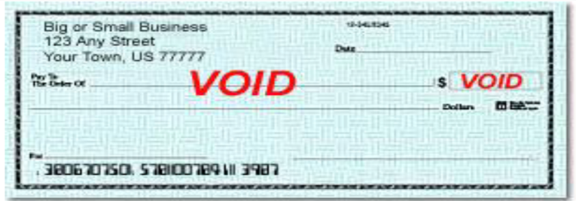

SECTION 2: Personal Information
Name: Email:
Street Address:
City: State: Zip:
Phone: ( )

AUTHORIZATION AGREEMENT FOR AUTOMATED WITHDRAWALS:
I hereby authorize and request the Islamic Cultural Center of Fresno (ICCF) to make monthly withdrawals in the amount listed above by initiating debit entries to my account indicated on the voided check copy or via my credit/debit card, and I authorize and request my bank (Name of Bank __________________________________________) to accept debit entries initiated by ICCF to such account. It is understood that this agreement may be terminated by me at any time by written notification to ICCF. Any such notification to ICCF shall be effective only with respect to entries initiated by ICCF after receipt of such notification and a reasonable opportunity to act on it.

Signature: Date:

Return to:
Islamic Cultural Center of Fresno
211 E. Nees Avenue
Fresno, CA 93720
559-297-9535

